**Gakina waabam ma’iingan   
ezhi-bimibatood!**(Run like a wolf!)

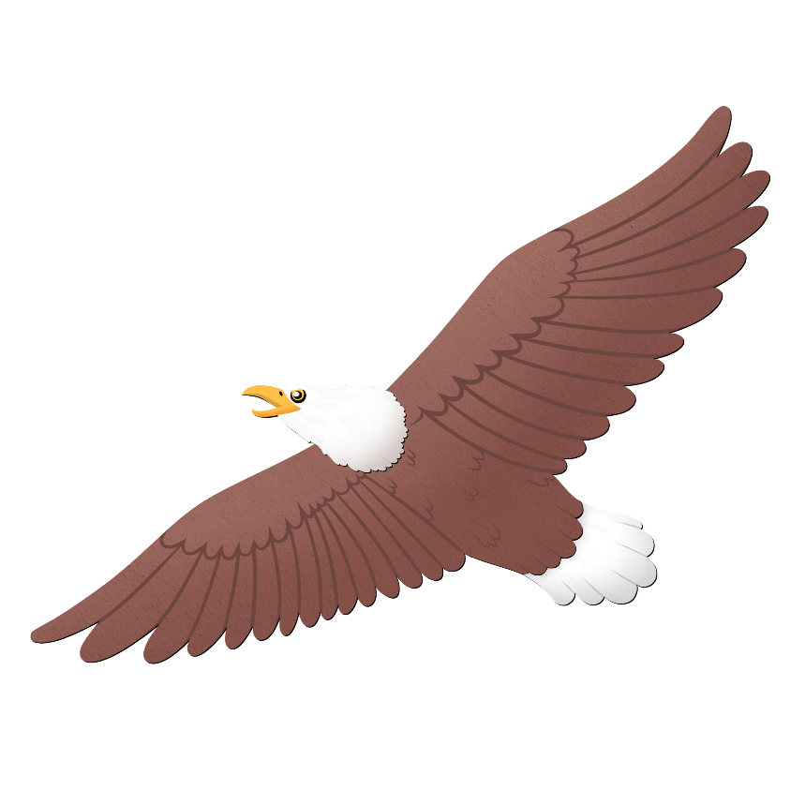

**Gakina waabam migizi   
ezhi-bimised!**(Fly like an eagle!)

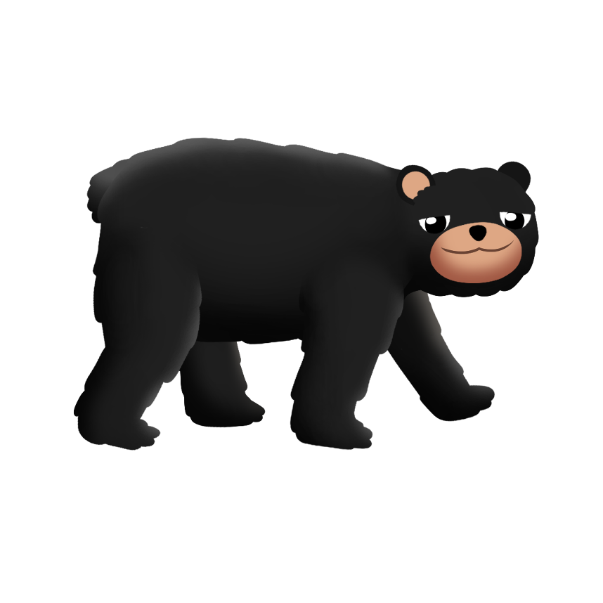

**Gakina waabam makwa   
ezhi-bimosed!**(Walk like a bear!)

**Gakina waabam name   
ezhi-bamaadaged!**(Swim like a sturgeon!)

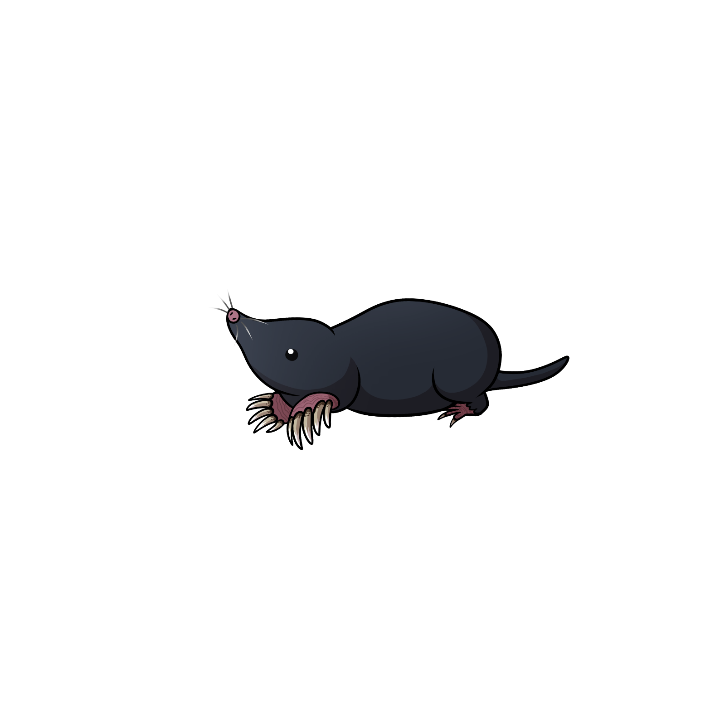

**Gakina waabam nenepaajinikesi   
ezhi-waaniked!**(Dig like a mole!)

**Gakina waabam ginebig   
ezhi-bimooded!**(Slither like a snake!)